Steps to raise request for SecureID token:

Step 0 : Install secureID token app into your mobile (new employee) and pass on binding id and device type to manager or buddy.

Step 1: Navigate to <https://dash.fisglobal.com/> (buddy/ manager)

Step 2: Click on Submit new request. (buddy/ manager)

Step 3: Click on EIAM Employee Requests then Click on Soft/Hard token (buddy/ manager)

Follow below steps in screenshot:

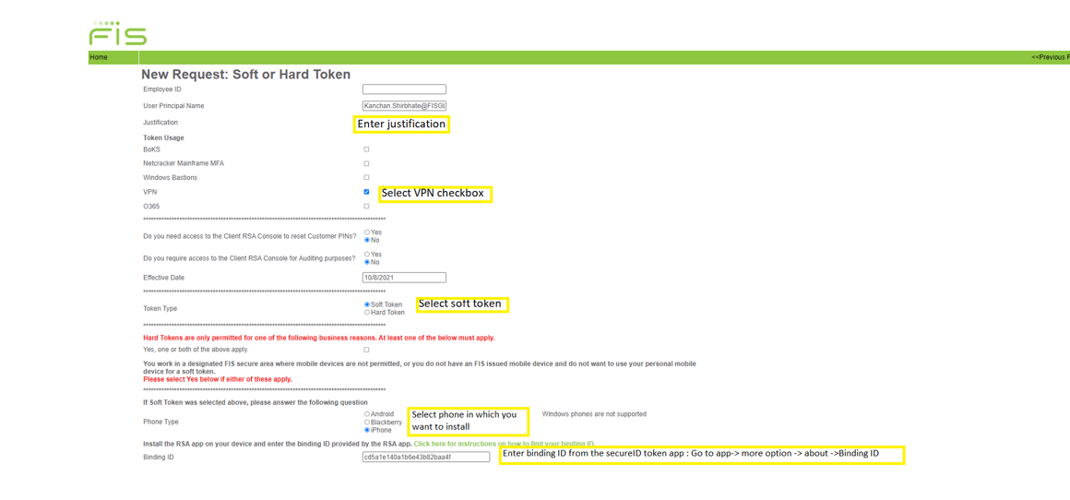

Step 4: Click on submit request (buddy/ manager)

(Waiting period – buddy/ manager to watch email box and forward token details)

Step 5: Scan QR code which you have received

Step 7:   
*a. Navigate to* [*https://ssp.fnfis.com/login*](https://ssp.fnfis.com/login) *b. Enter your employee id (e or lc) in the Username field.*

Step 8: Go to secureID token app  
**Soft Token:** To get the soft token passcode, leave the Enter SecuriID PIN field blank and tap submit. Enter respective code

Step 9: Set new pin and confirm pin  
  
Step 10: Try to login VPN by entering pin in secureID token and enter passcode.  
  
Step 11: VPN login successful